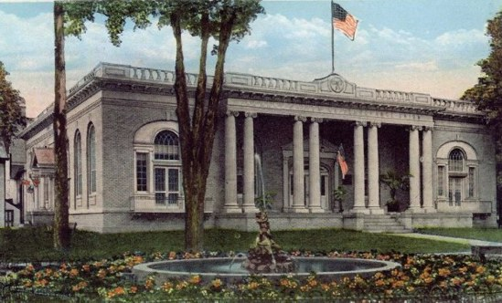

Hunt Memorial Preservation Committee, Inc.

PO Box 719
Ellenville, NY 12428

Email – huntpreservation@gmail.com

Website – huntmemorialbuilding.org

Board of Directors

President
Kathy Butler

Vice President

Jane Eck

Secretary
Debbie Davis

Treasurer
Leslie Levine

Ann Bowler
Bill Brown

Steve Bradley
Phyllis Lennert
Sally Minich
Stan Rubin

Brief History of HMPC and its mission to return the Hunt to community use.

In 2003, a group of citizens organized as the Hunt Memorial Preservation Committee, Inc. (or HMPC, as it is frequently called),
having as its purpose "to restore and preserve the architectural integrity and historical significance of the Hunt Memorial Building" and "to return it to a combined community/business use in keeping with John R. Hunt's original purpose."

The Hunt Memorial Building and its property are closely tied to the social history of the Village of Ellenville. Through the years, the Liberty Square portico of "The Hunt," and its lawns, have been used for most major community events. Clayton's Band performances have been succeeded by summertime Music in the Square; 9/11 memorial ceremonies fill the Square with firemen and fire equipment; Memorial Day, Veterans Day, the Blueberry/Huckleberry Festival are all annual events and ceremonies that make use of "The Hunt." The "old" library rooms with their tall windows provide excellent daylight for art shows.

The HMPC believes that a building which has served the community-at-large for more than three-quarters of a century is deserving of historic status and preservation.

Thanks to HMPC's efforts, effective 2005, the Hunt Memorial Building on Liberty Square became the first Ellenville building to receive national status as an historic landmark (and has also received state and local landmark designations).

The HMPC, Inc., is a not-for-profit membership corporation open to anyone who agrees with the organization's purposes. It is governed by a nine-member Board of Directors, three of whom are elected annually for three-year terms at an annual meeting in November.

Members of the 2015 Board of Directors are: Kathleen Butler-President , Ann Bowler , Debbie Davis (Recording Secretary), Phyllis Lennert (Correspondence Secretary), Leslie Levine (Treasurer), Jane Eck (Vice President) , Bill Brown, Sally Minich, Stephen Bradley and Stan Rubin. The HMPC is incorporated, a 501(c)(3) tax-exempt membership organization which seeks funding for restoration activities through grants, member items, donations, and activities.

CONTACT INFORMATION
Kathy Butler – President HMPC (647-6943 , kathyb12428@gmail.com)
Jane Eck – Vice President HMPC (647 7141 , djeck41@verizon.net)

